A Report

on

Placement Management System

carried out as part of the course CSE CS2232 Submitted by

Vedic Varma

229302083

IV-CSE

in partial fulfilment for the award of the degree

of

BACHELOR OF TECHNOLOGY

In

Computer Science & Engineering

Department of Computer Science & Engineering,
School of Computer Science and Engineering,
Manipal University Jaipur,
April 2024

A Report

on

Placement Management System

carried out as part of the course CSE CS2232 Submitted by

Vedic Varma

229302083

IV-CSE

in partial fulfilment for the award of the degree

of

BACHELOR OF TECHNOLOGY

In

Computer Science & Engineering

Under the Guidance of :

Guide Name : Dr.Dibakar Sinha

Guide Signature : ………………………………………

Acknowledgement

This project would not have been completed without the help, support, comments, advice, cooperation and coordination of various people. However, it is impossible to thank everyone individually; I am hereby making a humble effort to thank some of them.

I acknowledge and express my deepest sense of gratitude to my internal supervisor Dr.Dibakar Sinha for his/her constant support, guidance, and continuous engagement. I highly appreciate his technical comments, suggestions, and criticism during the progress of this project “Placement Management System”.

I owe my profound gratitude to Dr. Neha Chaudhary , Head, Department of CSE, for her valuable guidance and for facilitating me during my work. I am also very grateful to all the faculty members and staff for their precious support and cooperation during the development of this project.

Finally, I extend my heartfelt appreciation to my classmates for their help and encouragement.

229302083 Vedic Varma



Department of Computer Science and Engineering
School of Computer Science and Engineering

Date: 17 April 2024

CERTIFICATE

This is to certify that the project entitled Placement Management System is a bonafide work carried out as Web Tech Midterm Assessment (Course Code: CS2232) in partial fulfillment for the award of the degree of Bachelor of Technology in Computer Science and Engineering, by Vedic Varma bearing registration number 229302083, during the academic semester IV of year 2023-2024.

Place: Manipal University Jaipur, Jaipur

Name of the project guide: Dr. Dibakar Sinha

Signature of the project guide: ______________________

Contents
Page No.
Cover page

Certificate
Abstract

Table of Contents (with page nos)

- Introduction
  - Objective of the project
  - Brief description of the project
  - Technology used
    - H / W Requirement
    - Software Requirement
  - Organization Profile (if applicable)
- Design Description
  - Flow Chart
  - Data Flow Diagrams(DFDs)
  - Entity Relatoinship Diagram(E-R Diagram)
- Project Description
  - Data Base
  - Table Description
  - File/Database Design
- Input/Output Form Design
- Testing & Tools used (if applicable)
- Implementation & Maintenance (if applicable)
- Future scope
- Conclusion
- Bibliography

- Introduction

  - Objective of the Project

The primary objective of this project is to develop a Placement Management System that simplifies and streamlines the student placement process in educational institutions. By automating tasks that were traditionally performed manually, such as updating spreadsheets, the system aims to enhance the efficiency and accuracy of placement management.

  - Brief Description of the Project

The Placement Management System is a web-based application designed to facilitate the management of student placements. It features a user-friendly interface for adding and viewing student data, and filtering options based on various criteria. The system provides functionalities for tracking the status of each student’s placement process, ensuring data security through user authentication, and sending automated email notifications to inform students of their placement status.

  - Technology Used
    - Hardware Requirement
- None specified, as it is a web-based application primarily requiring a server. Currently functioning on an AWS cloud hosted linux server

    - Software Requirement
- Front-End: React.js
- Back-End: PHP
- Database Management: MySQL or suitable RDBMS
- Web Server: Apache or Nginx
- Development Tools: Visual Studio Code, Git for version control
- Security Tools: SSL certificates, Firewalls
- Testing Frameworks (React Testing Library)

2. Design Description
2.1 Flow Chart
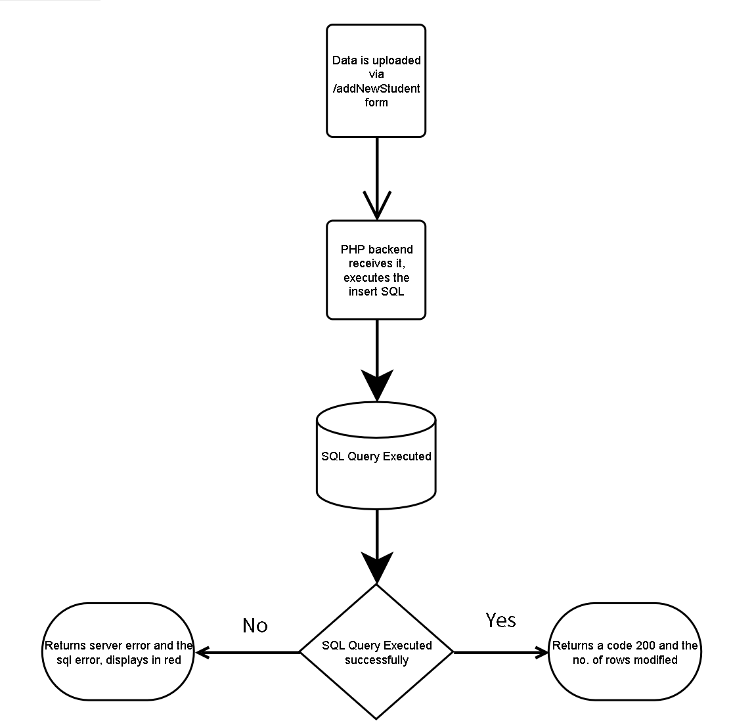
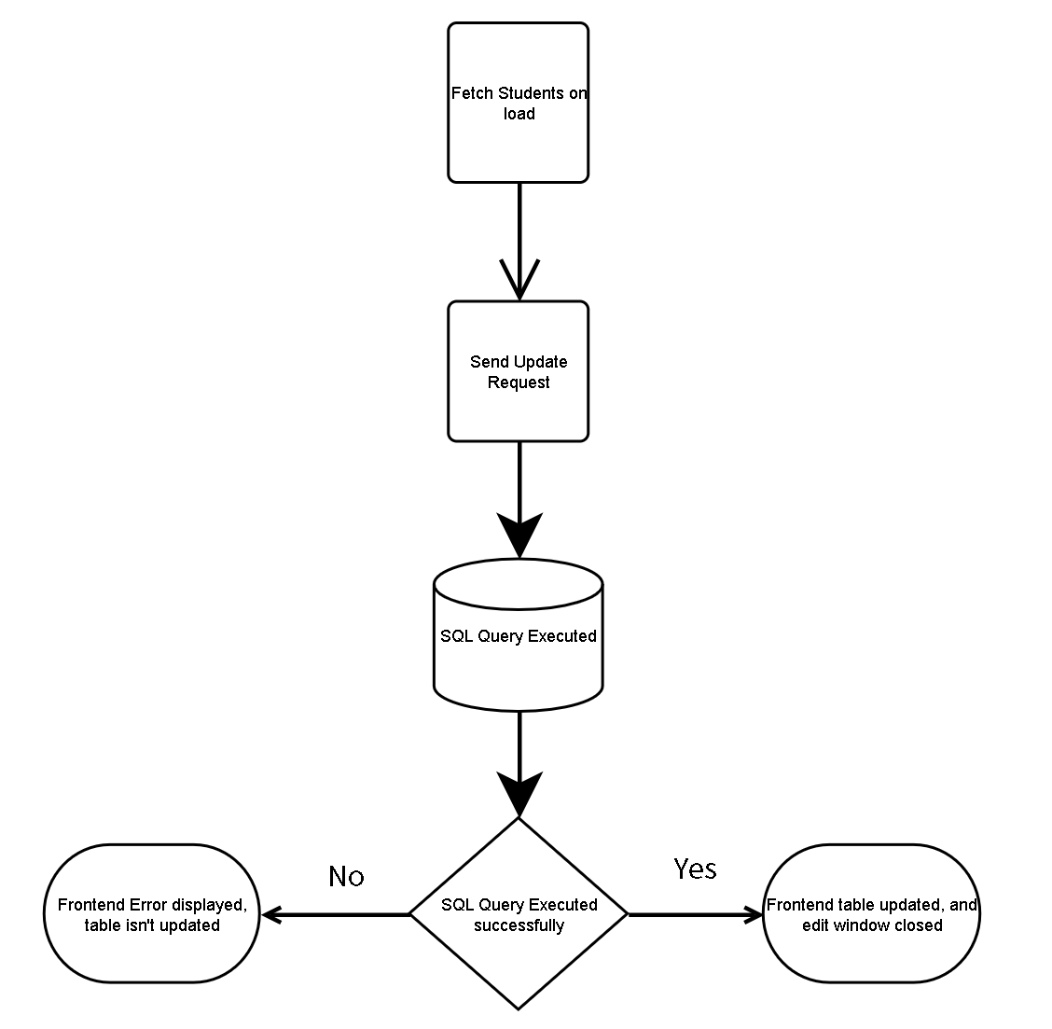
2.2 Data Flow Diagrams (DFDs)

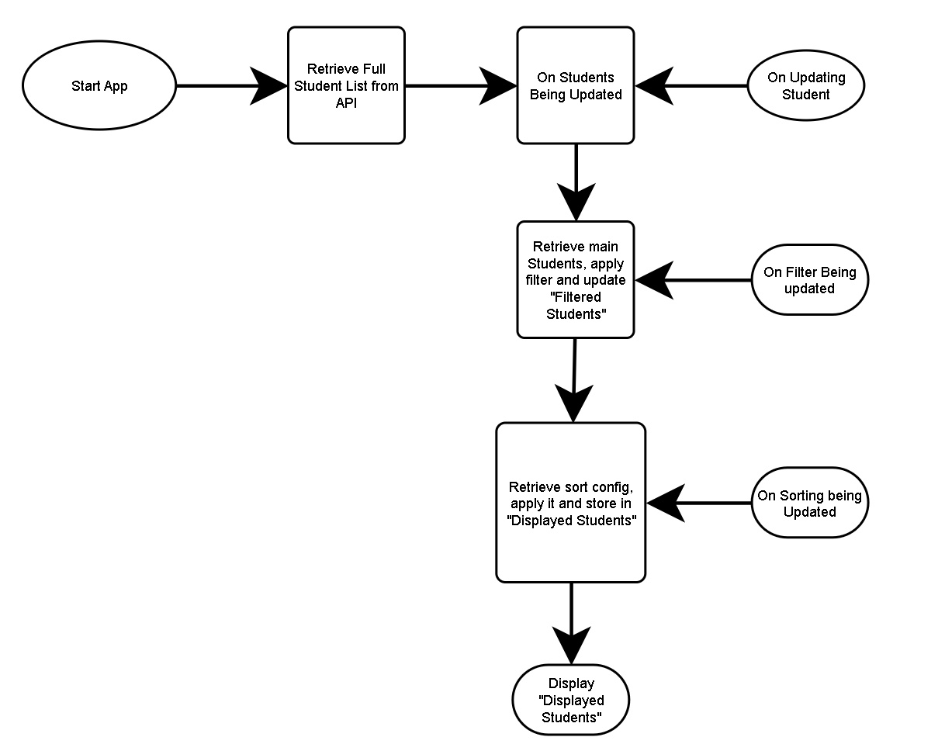

2.3 Entity Relationship Diagram (E-R Diagram)

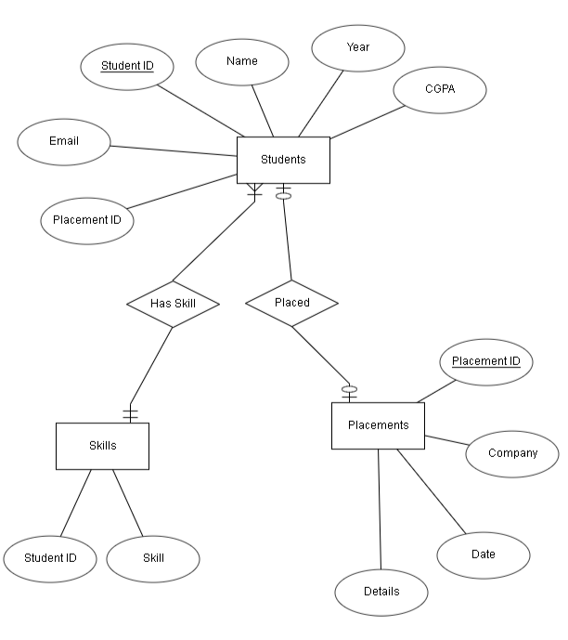

3. Project Description
3.1 Database
The system uses PHP My Admin along with MySQL to store the data locally on the system. This is to be migrated to a cloud hosted database in the future for ease of access for customers globally.

3.2 Table Description
The system relies on four core tables within the Supabase database:
- students: This table holds data about the students.
  - Student_id (primary key): Unique identifier for each student.
  - Name: Student’s full name.
  - Email: Employee's email address (used for login and notifications).
  - Year: Which year the student is in.
  - CGPA: the current CGPA of the student
  - Placement_ID(foreign key): The foreign key for the placement table
- Placements: This table stores information about where students get placed.
  - Placement_ID (primary key): Unique identifier for each placement.
  - Student_id (foreign key): References the student who was placed.
  - Company: The company name the student was placed at.
  - Date: The date the student was placed.
  - Details: The package, and other details of the placement
- skills: This table is meant to be taking care of the “Multivalued” aspect of the Students table, it has the following columns
  - Student_Id: The student in question.
  - Skill: The Skill the student has.
Note: Primary key is composite, consisting of (Student_Id, Skill)

4 . Input/Output Form Design
The system features user-friendly forms for various user roles:
- Add New Student / Placement:
  - Here a basic form is provided where one can fill in student details, such as Student ID, name, year, cpga, email, placement ID
  - Furthermore, a new placement can also be generated by creating a new row in the placements table
  - Both use axios.post() to submit their request to the php backend, which will update the MySQL table, then return the success/error code.
  - I have implemented a “notif” feature, where on submitting any form, the response from it will be stored in a state variable, notif. Depending on whether it was an error or success notif, the returned message will be shown to the user in a green or red text box at the top of the application.
- Dashboard
  - Here 2 components are shown, Filterbox and StudentList.
  - Filterbox is just a small collapsible box holding a few inputs/labels in the form of a html form, which, on submitting, will apply a certain filter onto the main “students” state variable, and then store that data in a state “filtered Students”.
  - StudentList is a dynamic html table that shows all the students informations, based on the “filtered Students” received from the Filterbox. After filtered Students have been changed, a “SortConfig” is also applied to the array, then that is stored in “Displayed Students”, which is then spawned in the form of <tr> table rows in the table.
  - Sorting is implemented by clicking on the column headers.
  - Context menu is replaced by a form of ‘resetting’, meaning, right clicking on an input in the filterbox will reset the filter and submit it simultaneously, right clicking on any header will reset the sort config for that header specificically and respawn the table.
  - Updating is also implemented by using “double click”. I’ve implemented a state variable, editing ID, which changes all the empty text in the <td> to input boxes, where we can change the information, then enter to send the update request to my backend.

5. Testing & Tools used
For the placement management system, a rigorous testing strategy is crucial to ensure reliability and optimal performance. Here's a breakdown of the testing approach and tools utilized:

- Unit Testing: Individual components such as database interactions (inserts, updates), form validations, and backend APIs are tested separately to ensure they function correctly in isolation.

- Integration Testing: This stage tests the integration between various components such as the communication between the front end and the backend, and between the backend and the database. This helps ensure that data flows correctly throughout the application and that components work together as expected.

- API Testing: Critical for ensuring the backend APIs function correctly when interacting with the frontend and the database. I used Thunder Client to make sure that all the apis are functioning as expected and there are no unexpected errors.

- End-to-End Testing (E2E Testing): Simulates user interactions from beginning to end to ensure the system works as a whole. This includes testing the process from adding a new student or placement to viewing and updating their details.

- Manual Testing: Manual testing by real users is also vital, especially for user interface and usability testing. It helps identify unexpected behaviors and UI issues that automated tests may miss. This was done by giving my roommate full access to the project, and having them implement E2E testing by simulating a placement manager.

6. Implementation & Maintenance

5.1 Implementation
The implementation process for the placement management system involves several key stages:
- Environment Setup: Setting up the development and production environments, including configuring servers, databases, and necessary software dependencies.
- Development: Coding the system's functionalities, including frontend user interfaces, backend services, and database management features, with an emphasis on clean, maintainable code.
- Testing and Deployment: Comprehensive testing is conducted as described earlier. After successful testing, the system is deployed to a production environment where it becomes available for actual use.
- User Training: Training sessions for users, which may include administrators and staff who will manage the placement process, ensuring they are familiar with system features and functionalities.

6.2 Maintenance
Ongoing maintenance is critical to address any arising issues and adapt to new requirements:
- Bug Fixes: Regular monitoring and fixing of any issues to ensure the system operates smoothly.
- Security Updates: Keeping the software up-to-date to protect against vulnerabilities, especially important given the sensitive nature of student data.
- Feature Enhancements: Based on user feedback, additional features and improvements should be periodically implemented to enhance functionality and user experience.
- Data Backups: Regular backups to prevent data loss and provide data recovery options in case of failures.

7. Future Scope

Looking forward, several enhancements can be made to the placement management system:
- Integration with Broader Educational Tools: Linking the system with other educational management tools or platforms to provide a comprehensive suite for educational institutions.
- Advanced Reporting Tools: Developing sophisticated reporting features for better tracking of placement trends, student performance, and other analytics.
- Mobile App Development: Creating mobile applications to allow students and staff to access the system on the go.
- Enhanced Data Privacy Features: Implementing stronger data protection features to safeguard student information, especially as the system might move to a cloud-based solution.
- Customizable Features: Allowing institutions to customize various aspects of the system according to their specific needs and workflows.
These enhancements will ensure the system remains robust, flexible, and capable of meeting evolving user needs.

8. Conclusion

The Placement Management System developed as part of this project presents a robust tool designed to automate and enhance the student placement processes in educational institutions. This system not only simplifies data management but also ensures that the placement activities are carried out more efficiently and effectively. By integrating technologies like React.js for the front-end and PHP for the backend, coupled with a MySQL database, the system provides a comprehensive solution that supports real-time data processing and a user-friendly interface. The system's potential for scalability and integration with additional modules indicates its capability to evolve and adapt to future educational needs and technologies. Overall, the Placement Management System stands as a testament to how automation and digital management tools can significantly improve administrative processes in educational contexts, thereby benefiting both the institutions and their students.

9. Bibliography

- React Documentation: (Accessed on April 2, 2024) React, "React – A JavaScript library for building user interfaces." https://reactjs.org/docs/getting-started.html
- PHP Manual: (Accessed on April 4, 2024) PHP, "PHP: Hypertext Preprocessor." https://www.php.net/manual/en/index.php
- MySQL Documentation: (Accessed on April 4, 2024) MySQL, "MySQL 8.0 Reference Manual." https://dev.mysql.com/doc/refman/8.0/en/
- Apache Documentation: (Accessed on April 4, 2024) The Apache Software Foundation, "Apache HTTP Server Version 2.4 Documentation." https://httpd.apache.org/docs/2.4/
- Visual Studio Code: Microsoft, "Visual Studio Code - Code editing. Redefined." https://code.visualstudio.com/
- Git Documentation: (Accessed on April 8, 2024) Git, "Git SCM." https://git-scm.com/docs
- SSL Certificates Guide: (Accessed on April 7, 2024) SSL.com, "SSL/TLS Certificates." https://www.ssl.com/guide/
- React Testing Library: (Latest version as of April 12, 2024) Testing Library, "React Testing Library." https://testing-library.com/docs/react-testing-library/intro/

